
Greenwood College

Methods 1 & 2
INVESTIGATION 1 2018

(Number & Algebra)

Take-Home Section.

NAME: ____________________

At Steven’s fruit stand, oranges are stacked in the shape of a square-based pyramid.
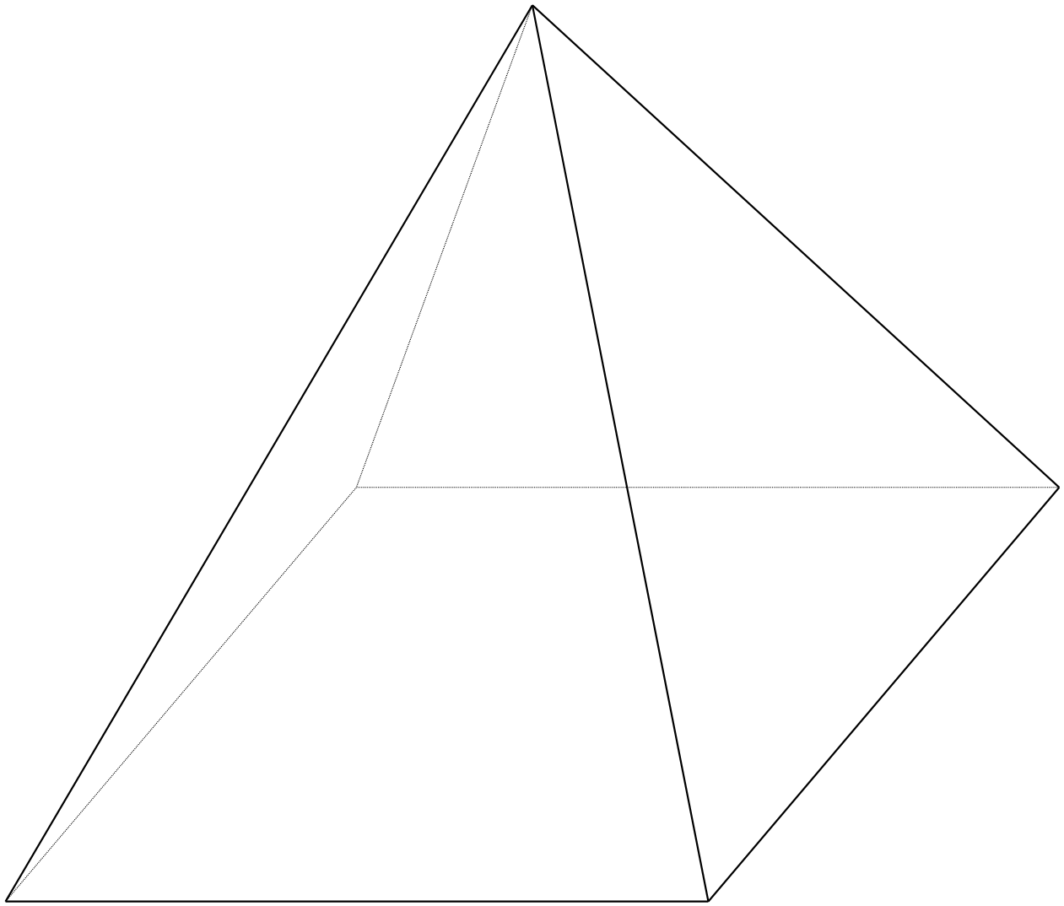

Steven needs a formula to help make decisions about stacking fruit. He wants to know:
- How many oranges should be arranged in the bottom layer (the xth layer from the top)?
- How many oranges (y) can be stacked in a pyramid with x layers?

He counts the oranges in the top layer, the top two layers, the top three layers, and the top four layers – then records his results in a table.

x = 1
x= 2
x= 3
x= 4

x | y
1 | 1 = 1
2 | 1 + 4 = 5
3 | 1 + 4 + 9 = 14
4 | 1 + 4 + 9 + 16 = 30
5
6
7
8
9
10

1. Use Steven’s’ table to find the number of oranges in:
    - The 10th layer.

    - The entire pyramid with 10 layers.

To find the formula for y in terms of x, Steven makes a difference table. Note: He also includes an imaginary value for y when x = 0 (the 0th layer).

x | y | 1st difference | 2nd difference | 3rd difference
0
1 | 1
 |  | 4
2 | 5 |  | 5
 |  | 9
3 | 14 |  | 7
 |  | 16
4 | 30
5

iii) Complete Steven’s table by filling in the numbers missing from the shaded boxes.

iv) After carefully evaluating the completed difference table, Steven concludes that the relationship is not a linear or quadratic but a third-degree equation. This is also called a cubic equation. Explain his reasoning.

v) Complete the following difference table for the general cubic equation:
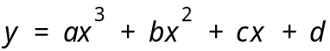

x | y | 1st difference | 2nd difference | 3rd difference
0 | d
 |  | a+b+c
1 | a+b+c+d |  | 6a+2b
 |  | 7a+3b+c |  | 6a
2 | 8a+4b+2c+d |  | 12a+2b
 |  | 19a+5b+c
3 | 27a+9b+3c+d
4
5

vi) Use the entries in Steven’s and the general cubic difference table to help you find
a, b, c, and d.

vii) Write an equation that can predict the number of oranges (y) for a square pyramid with x layers.

viii) Steven finds the following formula in a college textbook:

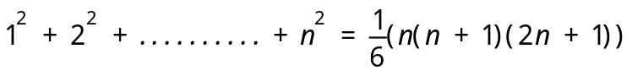

Does this formula also give the total number of oranges in a square pyramid with n layers?

2. Zac challenges Lachlan to find the total number of squares on an 8 x 8 chessboard. Lachlan begins by counting all the possible squares on some simpler boards:
1 x 1 2 x 2 3 x 3 and so on.

The following table shows her results:

Size of board | 1 x 1 squares | 2 x 2 squares | 3 x 3 squares | 4 x 4 squares | Total squares
1 x 1 | 1 | - | - | - | 1
2 x 2 | 4 | 1 | - | - | 5
3 x 3 | 9 | 4 | 1 | - | 14
4 x 4 | 16 | 9 | 4 | 1 | 30

i) Use patterns you find in the table to help solve Lachlan’s problem for an 8 x 8 chessboard. Try constructing a difference table to come up with an equation.

ii) Find a formula for the total number of squares on an n x n chessboard.

3. Mosie works at a grocery store. He stacks cans of beans in triangular pyramids. The diagram shows the top three layers.
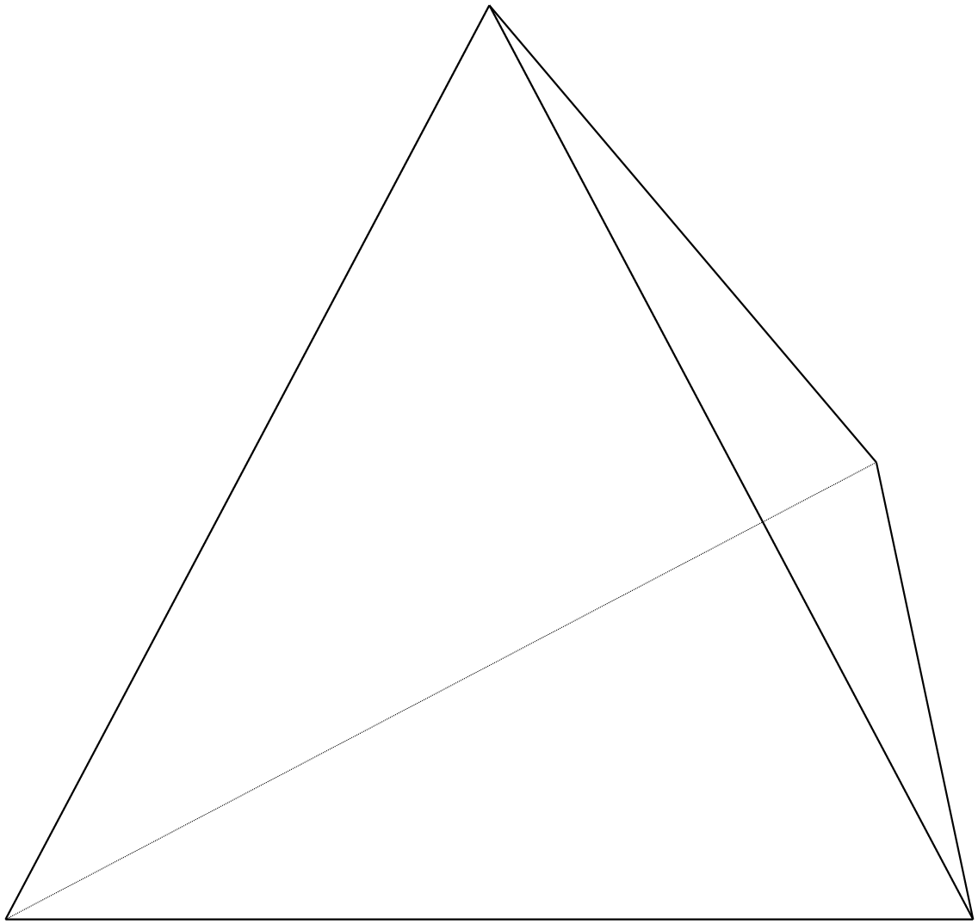
x = 3
x = 2
x = 1
i) Find a formula for the number of cans (y) in a pyramid with x layers.

4. Construct a difference table and find a formula for each of the following:

a.
x | y
0 | 0
1 | 2
2 | 10
3 | 30
4 | 68

b.
x | y
0 | 0
1 | 3
2 | 14
3 | 39
4 | 84

c.
x | y
0 | ?
1 | 2
2 | 4
3 | 0
4 | -16
5 | -50

